|  |  |  |  |
| --- | --- | --- | --- |
| **F:\Learning bugs\Foundation Subjects\Dolly the Fly - Science.jpgLyng Primary School Knowledge Organiser** | | | |
| **Topic:** | **Light and reflection** | **Year 6** | **Autumn 2** |

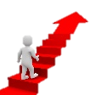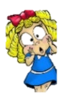

**What should I already know?**Pupils will build on the work on light in Year 3, exploring the way that light behaves, including light sources, reflection and shadows. They should talk about what happens and make predictions.

**Notable scientists**

Isaac Newton (triangular prism).

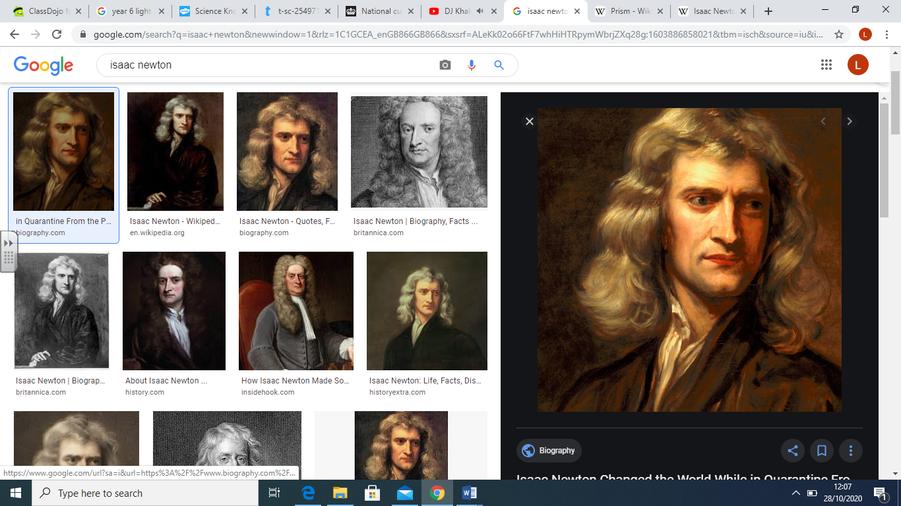

|  |  |
| --- | --- |
| **What Step On and Goldilocks words will I use?** | |
| **Spelling** | **Definition** |
| incident ray | A ray of light that hits a surface. |
| light | A form of energy that travels in a wave from a source. |
| light source | An object that makes its own light. |
| opaque | Describes objects that do not let any light pass through them. |
| prism | A solid 3D shape with flat sides. A transparent prism separates out visible light into all the colours of the spectrum. |
| reflected ray | A ray of light that has bounced back after hitting a surface. |
| reflection | When light bounces off a surface, changing the direction of a ray of light. |
| refraction | When light bends as it passes from one medium to another. |
| shadow | An area of darkness where light has been blocked. |
| the law of reflection | The law states that the angle of the incident ray is equal to the angle of the reflected ray |
| translucent | Describes an object that does not let all the light through - difficult to see through it clearly. |
| transparent | Describes a see-through object that lets light travel through them easily. |
| visible spectrum | Light that is visible to the human eye; it is made up of a colour spectrum. |

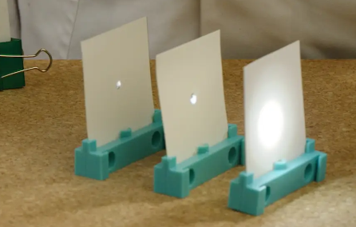

|  |
| --- |
| **Investigate!** |
| * Make observations about the properties of light. * Use my observations as evidence to support conclusions about light. * Draw ray diagrams. * Pose testable questions in response to observations. * Record my measurements as a line graph. * Use my line graph to extrapolate data and make predictions about missing values. * Recall various jobs or inventions that use mirrors and reflection. |

|  |
| --- |
| **Enquiry Questions** |
| * How does light travel? * How do we see? * How do our eyes work? * What affects the angle of the reflected ray? * How does a periscope work? * How are mirrors helpful? |

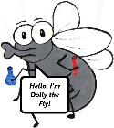

**What will I know by the end of the unit?**

|  |  |  |  |  |
| --- | --- | --- | --- | --- |
| Children will… | | | | |
| …recognise that light appears to travel in straight lines and use this idea to explain that objects are seen because they give out or reflect light into the eye. Children will be able to explain that we see things because light travels from light sources to our eyes or from light sources to objects and then to our eyes. | | | …use the idea that light travels in straight lines to explain why shadows have the same shape as the objects that cast them. Children learn that shadows are larger as an object moves closer to the light source; more light is blocked causing a larger absence of light or shadow. | |
| Light needs to enter the eye for us to be able to see. It enters through the pupil.    Light may come directly from a luminous object or reflect off a non-luminous object. | | | Mirrors are useful in lots of situations:   * Looking at the back of your hair when you get it cut. * Dentists looking inside your mouth. * Rear view and side mirrors in a car to look at your surroundings in a vehicle. * Periscopes are long, vertical tubes that contain a set of mirrors to give a view above the position of the eye. | |
| **F:\Learning bugs\Foundation Subjects\Dolly the Fly - Science.jpgLyng Primary School Knowledge Organiser** | | | | | |
| **Topic:** | **Science - Light** | **Year 6** | | **Autumn 2** | |

|  |
| --- |
| 1. Explain what reflection is (linking to light). |
| Start –  End – |

|  |
| --- |
| 5. How do shadows prove that light travels in straight lines? |
| Start –  End - |

|  |
| --- |
| 6. Match the vocabulary to the correct definition: |
| **START**    **END** |

|  |  |  |
| --- | --- | --- |
| 1. Which material allows light to pass through completely? | **S** | **E** |
| 1. Opaque |  |  |
| 1. Transparent |  |  |
| 1. Translucent |  |  |

|  |  |
| --- | --- |
| 1. Name three light sources.   START | END |
| 1) | 1) |
| 2) | 2) |
| 3) | 3) |

|  |  |  |
| --- | --- | --- |
| 1. What is the correct definition of refraction? | **S** | **E** |
| 1. A ray of light that has bounced back after hitting a surface. |  |  |
| 1. When light bounces off a surface, changing the direction of a ray of light. |  |  |
| 1. When light bends as it passes from one medium to another. |  |  |